Movie Recommendation Based On Emotion Using Web Scrapping

**INDEX:**

1.INTRODUCTION

2.LITERATURE SURVEY

3.THEORITICAL ANALYSIS

4.EXPERIMENTAL INVESTIGATIONS

5.FLOW CHART

6.RESULT

7.ADVANTAGES AND DISADVANTAGES

8.APPLICATIONS

9.CONCLUSION

10.FUTURE SCOPE

11.BIBILOGRAPHY

**Introduction:**

**Overview:**

1.Getting emotion as input from user

2.Getting the movie names from imdb by using flask

3.Displaying the movies for the user

**Purpose:**

It is not always easy to pick the right movie to watch.Sometimes you are in the state of mind to see individuals begin to look all starry eyed at,or you need a motion picture to remind your connection with emotion based movie.Sometimes they may be confuse to watch which movie.So we are Recommending Movies Based On your emotion.

**Literature Survey:**

To complete this project,we must require following softwares and packages:

**Anaconda Navigator:**

Refer the link to download anaconda3:

https://youtu.be/5mDYijMfSzs

To download required Packages

if you are using Anaconda prompt

* Type "pip install Flask"
* Type "pip install re"
* Type "pip install BeautifulSoup4"
* Type "pip install lxml"

**Theoritical Analysis:**

**Block Diagram:**

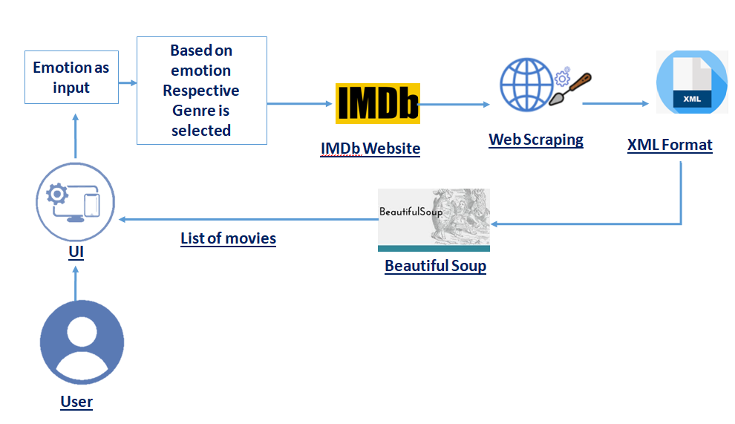

**Experimental Investigation:**

**Regular Expression:**

A regular expression is a special sequence of characters that helps you match or find other strings or sets of strings, using a specialized syntax held in a pattern.

**Requests:**

requests are a Python HTTP library.

The different types of HTTP requests are

**GET** request is the most common method and is used to obtain the requested data from the specific server.

**POST** is the most common request method used to send data mostly through 'form' to the server for creating/updating in the server

**Flowchart:**

• User interacts with the UI (User Interface) to enter the emotion

• Entered emotion is analyzed and the movie titles can be scraped from the IMDb list to recommend to the user

• The list of movies is showcased on the UI

To accomplish this,we have to complete tasks below

• Necessary Steps

• Build HTML Pages

• Import Necessary Libraries

• Creating our flask application

• Routing to the html Page

• Classify the emotion associated with Genre of Movie

• Scraping the Web Page

• Main Function

* Run the application

**Result:**

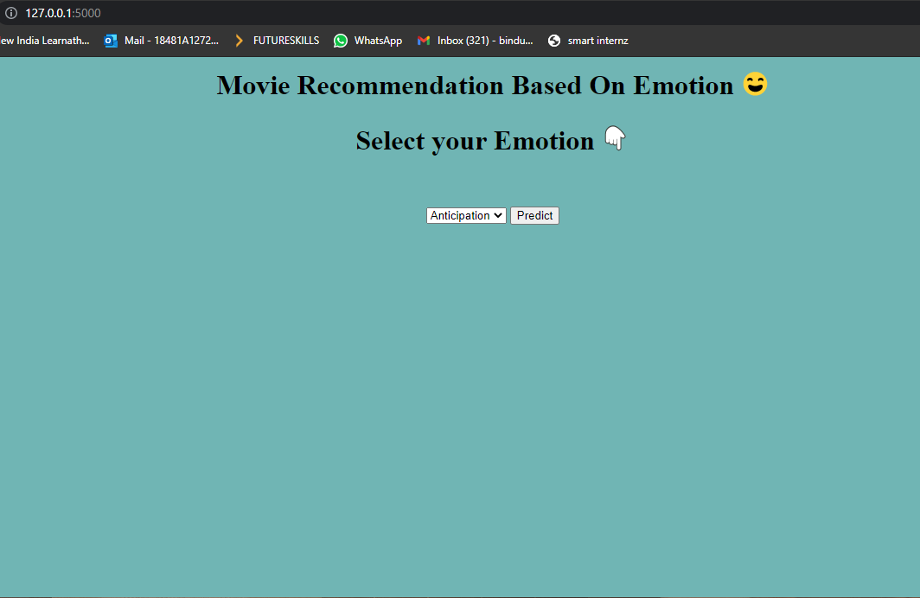

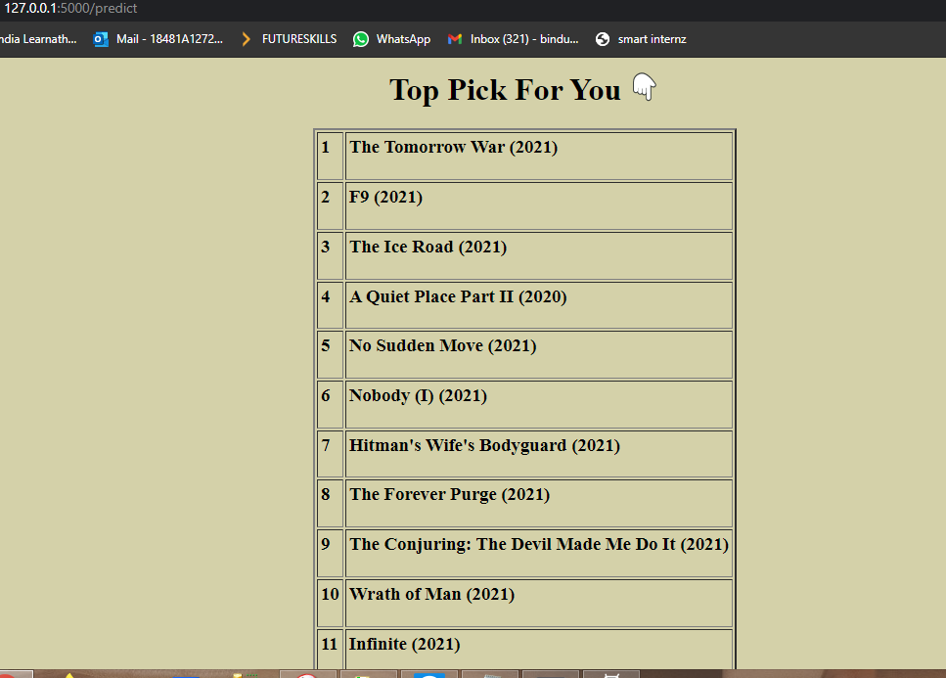

**Disadvantages:**

Recommending movies based on only emotion not by using rating etc...

**Advantages:**

more interact with users

**Conclusion:**

By the end of this project you will:

know fundamental concepts of Python.

gain a broad understanding of Web Scraping.

know how to install necessary packages and setting up the environment.

know how to build a web application using the Flask framework.

**Future Scope:**

Recommender systems help E-commerce sites to increase their sales. A movie recommendation system based on collaborative filtering approach makes use of the information provided by users, analyzes them and then recommends the movie that is best suited to the user at that time based on their emotion

**Bibliography:**

Search Movie Recommendation Based On Emotion in Python